2018-2019 Junior All State Audition Violin Excerpts (Page 1)

Excerpt 1: Symphony No. 4, Mvt 3, Schumann, Violin 1. Start at Trio, play all Six lines (no repeats). Quarter note= 140. (3/4 time)
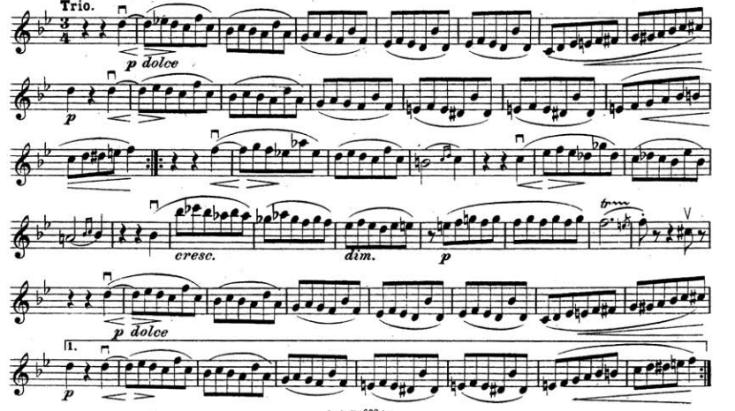

Excerpt 2: Symphony No. 29 Mvt 4, Mozart, Violin 1. Measures 96- until 4 after (E). Dotted Quarter note= 100 (6/8 time)

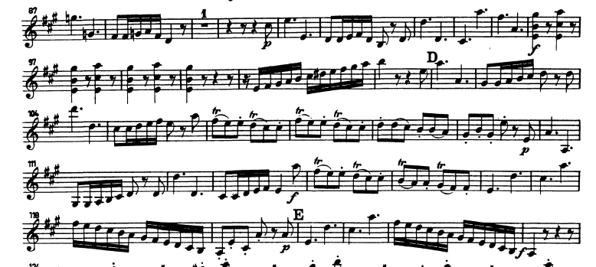

2018-2019 Junior All State Audition Viola Excerpts (Page 1/2)

Excerpt 1: Variations on a Theme by Haydn (Var VII), Brahms. Play Measures 303- 321 (Top Part). Dotted quarter note= 46 (6/8 time).

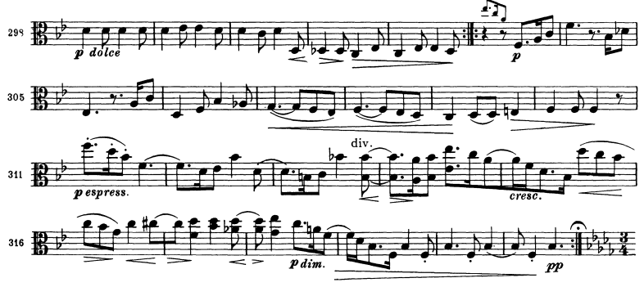

2018-2019 Junior All State Audition Viola Excerpts (Page 2/2)

Excerpt 2: Peer Gynt Suite Mvt 1, Grieg. Play Measures 2 before (D)- Downbeat of (E). Dotted Quarter note= 45 (6/8 time)
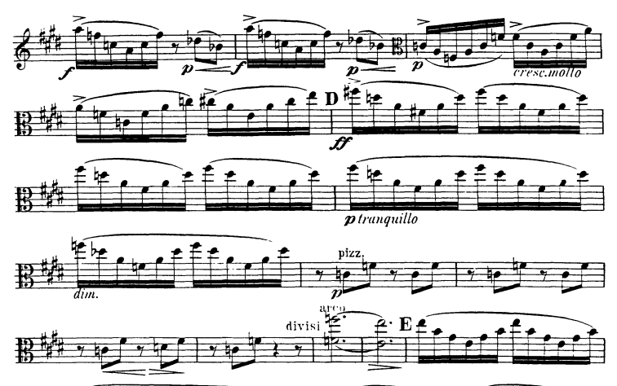

2018-2019 Junior All State Audition Cello Excerpts (Page 1/2)

Excerpt 1: Symphony No 8 in G Major Mvt. 1, Dvorak. Start at beginning through measure 18. Quarter note= 120.
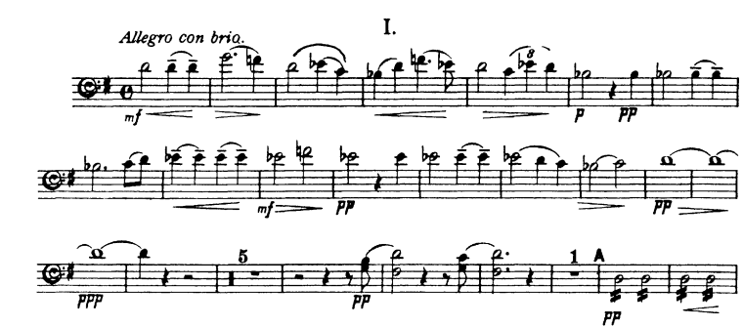

2018-2019 Junior All State Audition Cello Excerpts (Page 2/2)

Excerpt 2: Symphony No. 35, Mvt. 1, Mozart. Play Beginning- downbeat of 33 (A). Half note= 80 .
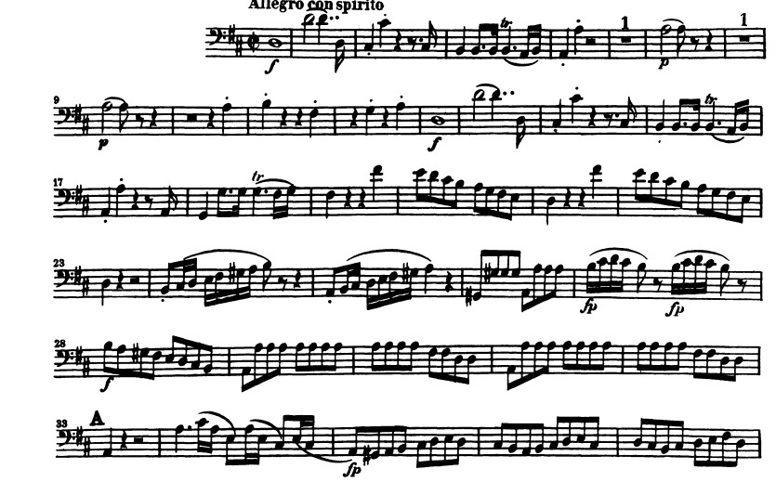

2018-2019 Junior All State Audition Bass Excerpts (Page 1/1)

Excerpt 1: Symphony No. 4, Tchaikovsky. Mvt 1, Beginning of excerpt to Downbeat of (C). Dotted Half note=75 (9/8 time).

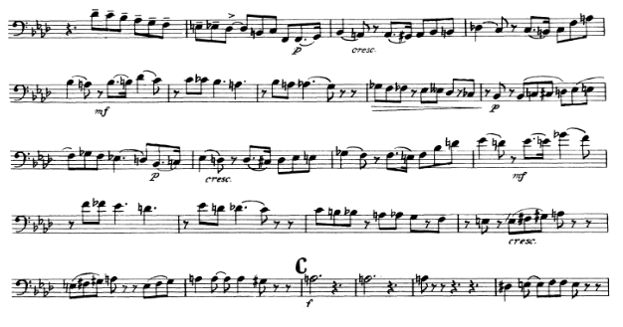

Excerpt 2: “In the Hall of the Mountain King” from Peer Gynt Suite, Mvt 4, Grieg. Play Piu Vivo (B)- downbeat of (D). Half note= 90 (4/4 time).

